Phase 7: Integration & External Access
Project: Debug Log Analysis and Bug Fixing in Salesforce Apex

1. Objective of Phase 7
The purpose of this phase is to integrate Salesforce DX project components and provide controlled external access to support testing and debugging.
Although the project primarily focuses on Apex code and debugging, integration ensures:
- Salesforce DX project communicates correctly with the org.
- Apex classes and test classes are deployable and executable.
- Replay Debugger can work seamlessly with generated debug logs.

2. Integration within Salesforce DX
Key integration steps include:
- Apex Class & Test Class Integration
  - AccountService.cls (logic) integrated with AccountServiceTest.cls (test).
  - Test class triggers execution of Apex logic and generates debug logs.
- Salesforce DX Project Structure Integration
  - All classes, metadata, and configuration are part of the DX project:
    - force-app/main/default/classes
    - sfdx-project.json for org connections
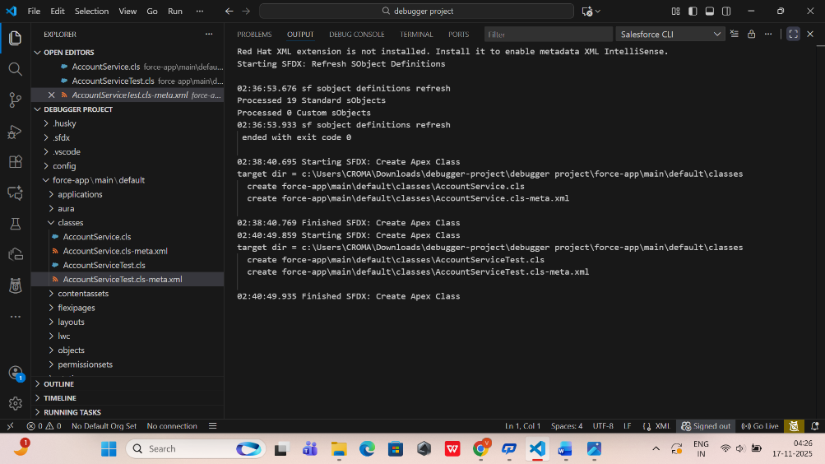

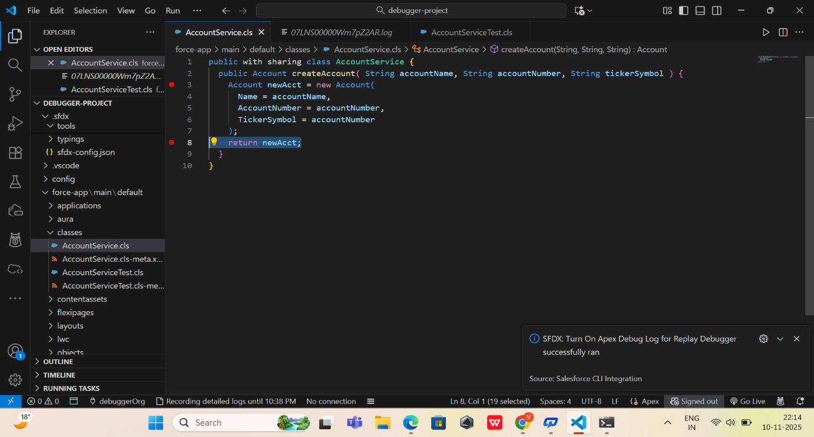

- UI Integration
  - The minimal Lightning Web Component (from Phase 6) connects with Apex class.
  - Allows manual triggering of methods to produce debug logs.
- Replay Debugger Integration
  - Debug logs generated during Apex execution are linked with breakpoints and checkpoints.
  - Ensures Replay Debugger correctly maps execution flow to code lines.

3. External Access Considerations
While the project does not require public external access, external integration can involve:
- Trailhead Playground / Scratch Org Access
  - Users (developers) authorize org via Salesforce CLI.
  - Access is required to deploy, run tests, and retrieve logs.
- API / Tool Access
  - CLI commands (sfdx force:apex:test:run, sfdx force:apex:log:get) act as external tools interacting with the org.
- Security & Authorization
  - Only authorized Salesforce users can execute Apex methods or view logs.
  - Protects sensitive data while allowing controlled debugging.

4. Benefits of Integration & Controlled External Access
- Centralized control of Apex code, test classes, and logs
- Simplified testing process across multiple orgs or environments
- Replay Debugger works consistently because code, logs, and breakpoints are aligned
- Developers can test, debug, and deploy safely without affecting production
- 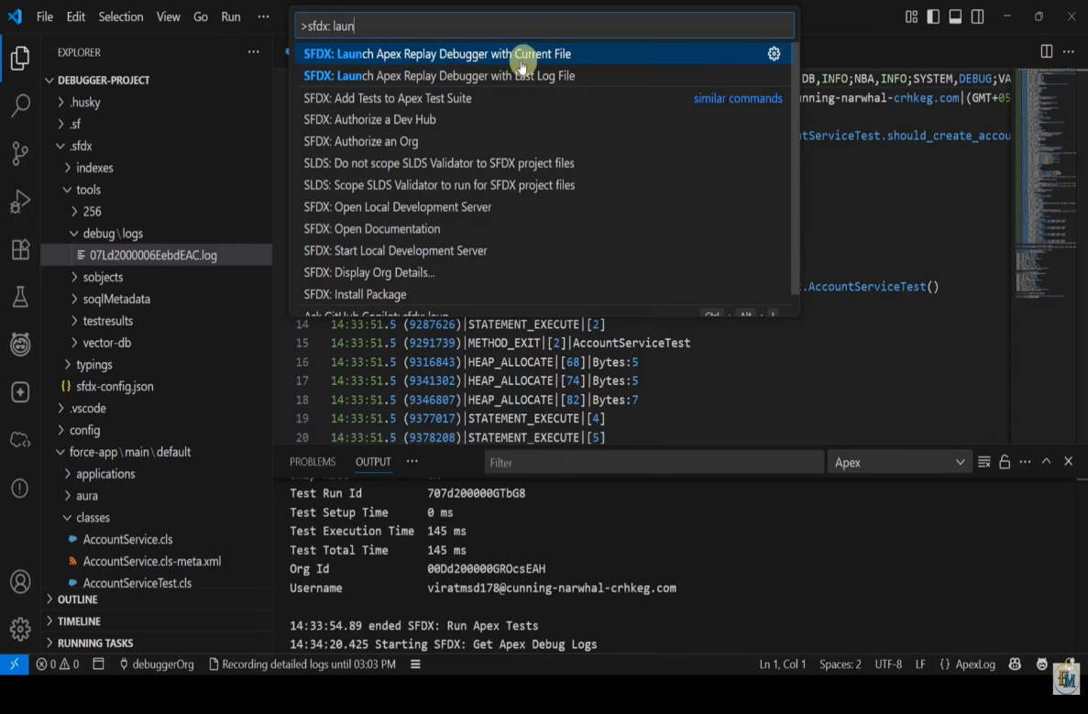

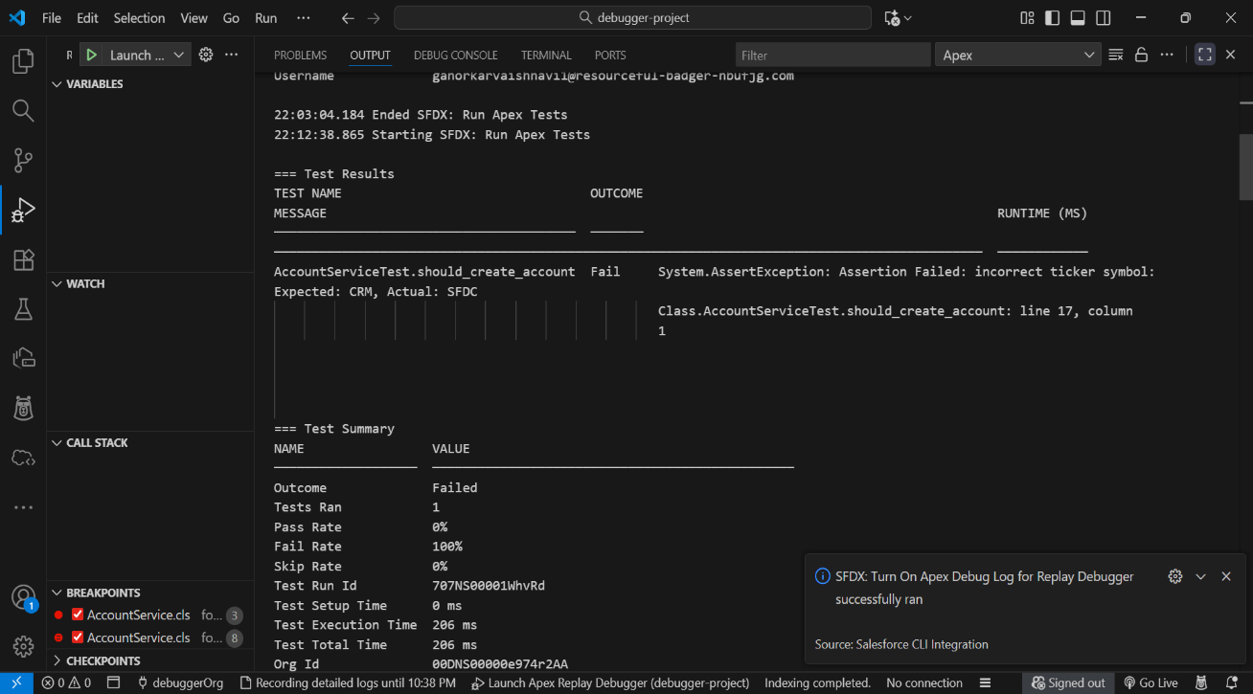

5. Deliverables of Phase 7
By the end of this phase:
✔ Apex classes, test classes, and UI fully integrated in DX project
✔ External access for authorized users via CLI or sandbox is configured
✔ Replay Debugger fully functional with integrated breakpoints and checkpoints
✔ Debugging workflow ready for real execution scenarios

6. Outcome
- Salesforce DX project is fully integrated and functional.
- Authorized developers can trigger Apex methods, run tests, and replay debug logs.
- Replay Debugger now works in a complete, end-to-end workflow from code → org → logs → debugging.

